### **AWS IAM Anywhere Setup Overview**

This document outlines the steps taken to set up AWS IAM Anywhere, enabling on-premises workloads to securely access AWS resources without the need for traditional access keys and secret keys. Instead, AWS IAM Anywhere relies on certificates to authenticate and authorize requests. Below are the steps I followed to configure this system using OpenSSL to generate the required certificates.

To use IAM Roles Anywhere, your workloads must use X.509 certificates issued by your [certificate authority (CA)](https://docs.aws.amazon.com/crypto/latest/userguide/pki-concepts.html#concept-ca). You register the CA with IAM Roles Anywhere as a trust anchor to establish trust between your public-key infrastructure (PKI) and IAM Roles Anywhere

## **IAM Roles Anywhere concepts**

* Trust anchors  
  You establish trust between IAM Roles Anywhere and your certificate authority (CA) by creating a *trust anchor*. A trust anchor is a reference to a CA certificate. Workloads outside of AWS authenticate with the trust anchor using certificates issued by the trusted CA in exchange for temporary AWS credentials.
* Roles  
  An [IAM role](https://docs.aws.amazon.com/IAM/latest/UserGuide/id_roles.html) is an IAM identity that you can create in your account that has specific permissions.
* Profiles  
  To specify which roles IAM Roles Anywhere assumes and what your workloads can do with the temporary credentials, you create a profile. In a profile, you can define IAM session policies, which can be managed or inline, to limit the permissions created for a session.
* The private key used to sign the request MUST be bound to an X.509 Certificate.
* The signing certificate MUST be a v3 certificate.
* The signing certificate's serial number MUST be included in the Credential portion

POC done using the personal AWS account and Personal Mac OS laptop. Below are the steps performed.

### **1. Generating the Certificate Authority (CA)**

First, I needed to create a **private CA** that would issue and sign the certificates for the on-premises machines. This private CA serves as the **Trust Anchor** in AWS IAM Anywhere.

I created the CA’s private key and self-signed certificate using OpenSSL:

#!/bin/bash

# Create CA private key

openssl genrsa -out MyAWSCA.key 4096

# Create CA certificate with the above-generated private key

openssl req -new -x509 -days 3650 -key MyAWSCA.key -out MyAWSCA.pem -extensions v3_ca -config ./openssl.cnf

* **MyAWSCA.key**: This is the private key for the CA, which is used to sign certificates.
* **MyAWSCA.pem**: This is the self-signed CA certificate, which will act as the **Trust Anchor** in AWS IAM Anywhere.

I uploaded MyAWSCA.pem to AWS IAM Anywhere as the **Trust Anchor** so that AWS can trust the certificates issued by this CA.

Create IAM Anywhere Trust Anchor

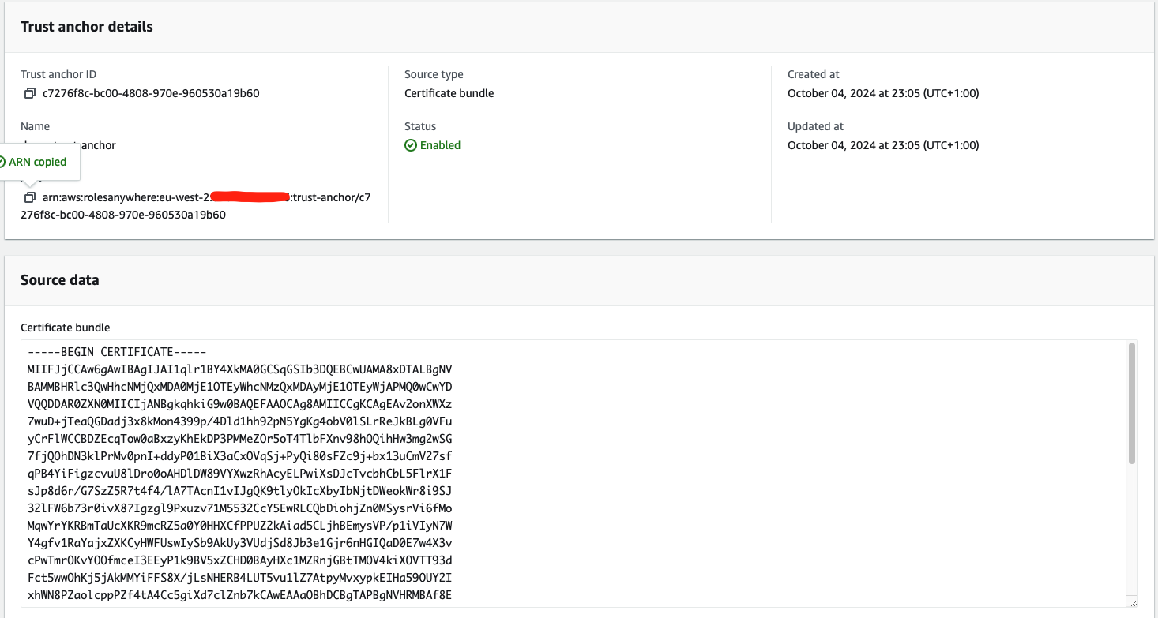

Create IAM Role and Policies

Attach the IAM Policies as required

Use the trust policy

{

"Version": "2012-10-17",

"Statement": [

{

"Effect": "Allow",

"Principal": {

"Service": [

"rolesanywhere.amazonaws.com"

]

},

"Action": [

"sts:AssumeRole",

"sts:TagSession",

"sts:SetSourceIdentity"

]

}

]

}

Create IAM Anywhere Profile

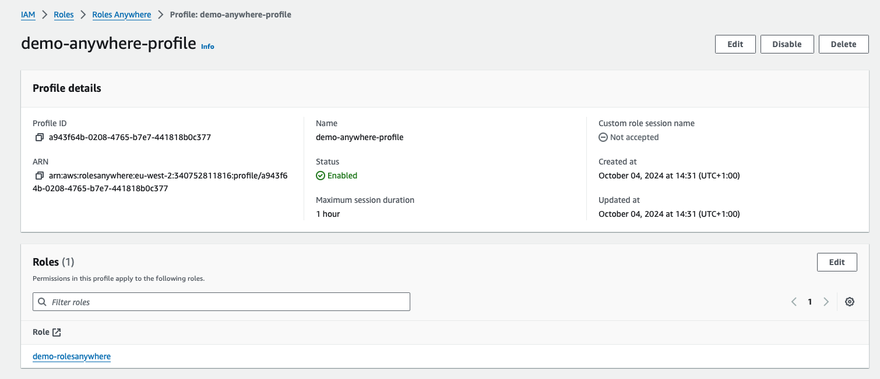

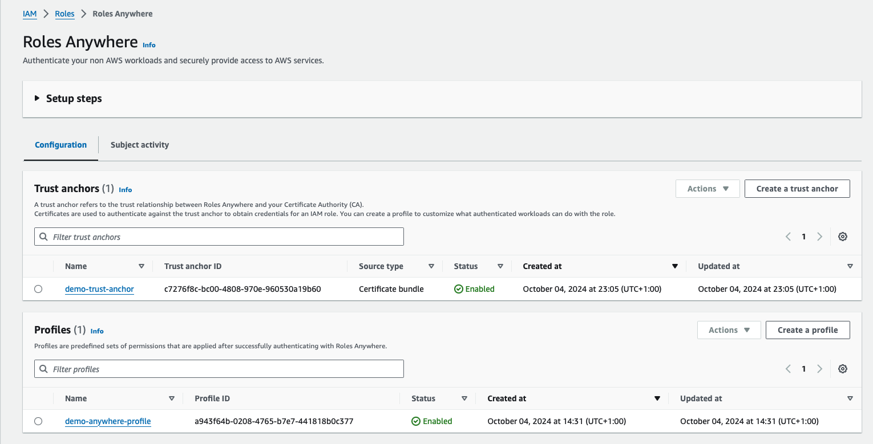

### **2. Generating the On-Premises Machine Certificates**

Next, I created a certificate for the specific on-premises VM that needs to authenticate with AWS. This process involved creating a private key and a Certificate Signing Request (CSR), then using the private CA to sign the CSR.

# Create on-premises private key (specific to the on-premises VM)

openssl genrsa -out onpremise.key 4096

# Create CSR (Certificate Signing Request) for the on-premises VM

openssl req -new -key onpremise.key -out onpremise.csr -config ./openssl.cnf

* **onpremise.key**: The private key specific to the on-premises VM, used for encryption and secure communication.
* **onpremise.csr**: The Certificate Signing Request generated using the private key, which will be signed by the CA to issue a valid certificate.

### **3. Signing the On-Premises Certificate Using the CA**

Once the CSR was created, I used the CA's private key and certificate (MyAWSCA.key and MyAWSCA.pem) to sign the on-premises CSR and issue the on-premises certificate.

# Create on-premises certificate by signing the CSR with the CA

openssl x509 -req -in onpremise.csr **-CA MyAWSCA.pem -CAkey MyAWSCA.key** **-CAcreateserial -out onpremise.pem** -days 3650 -sha256 -extfile onpremise.ext

* **onpremise.pem**: The signed certificate for the on-premises VM, which will be used to authenticate the machine with AWS.
* **onpremise.ext**: A configuration file defining specific certificate extensions, which I'll explain in detail below.
* **-CA MyAWSCA.pem**: Specifies the CA certificate used to sign the new certificate (onpremise.pem).
* **-CAkey MyAWSCA.key**: Specifies the private key of the CA, which is needed to prove that the CA has authority to issue the certificate.
* **-CAcreateserial**: Automatically generates a serial number for the new certificate and stores it in a file (MyAWSCA.srl).
  + Serial numbers help uniquely identify certificates issued by the CA. If you issue multiple certificates, this option ensures each one gets a unique serial number. The serial number file (e.g., MyAWSCA.srl) keeps track of the numbers so OpenSSL can avoid duplicates.

### **4. The Role of onpremise.ext**

The onpremise.ext file defines important attributes or **extensions** for the certificate. These extensions specify the certificate's intended usage and behavior, ensuring that the certificate is used correctly. Here’s the content of the file:

cat > onpremise.ext<<EOF

basicConstraints = CA:FALSE

authorityKeyIdentifier = keyid,issuer

keyUsage = nonRepudiation, digitalSignature, keyEncipherment, dataEncipherment

EOF

* **basicConstraints = CA**: This indicates that the certificate is an **end-entity certificate** and not a CA certificate. The on-premises machine cannot issue other certificates, ensuring proper use of roles.
* **authorityKeyIdentifier = keyid,issuer**: This identifies the certificate authority (CA) that issued the certificate, establishing a chain of trust back to the CA.
* **keyUsage = nonRepudiation, digitalSignature, keyEncipherment, dataEncipherment**: Specifies what the certificate can be used for, including:
  + **nonRepudiation**: The certificate holder cannot deny the signature.
  + **digitalSignature**: The certificate is used for signing data.
  + **keyEncipherment**: The certificate can be used to encrypt keys.
  + **dataEncipherment**: The certificate can be used to encrypt data directly.

The onpremise.ext file is essential as it ensures that the on-premises certificate follows proper security policies. Without these extensions, the certificate might not function as intended, especially in secure environments like AWS IAM Anywhere, where certificate usage must be clearly defined.

### **5. Configure AWS IAM Anywhere Credentials on the On-Premises Machine**

1. **Install the AWS IAM Anywhere Helper**:
   * Install the AWS IAM Anywhere signing helper tool on your on-premises machine if not done already. This tool uses the certificate and private key to authenticate requests.
   * <https://docs.aws.amazon.com/rolesanywhere/latest/userguide/credential-helper.html>
2. **Set Up AWS Credentials**:
   * Configure AWS credentials using the **certificate and private key** on the on-premises machine by updating the ~/.aws/credentials file:

### **6. Configuring AWS Credentials**

Finally, I configured AWS credentials on the on-premises machine to use the certificate for authentication. The AWS ~/.aws/credentials file was updated with a custom profile, using the client certificate and private key to authenticate via AWS IAM Anywhere:

[demo-anywhere-profile]

credential_process = /path/to/aws_signing_helper credential-process --certificate /path/to/onpremise.pem --private-key /path/to/onpremise.key --trust-anchor-arn arn:aws:rolesanywhere:region:account:trust-anchor/123456 --profile-arn arn:aws:rolesanywhere:region:account:profile/123456 --role-arn arn:aws:iam::account:role/demo-role

In this setup:

* **Trust Anchor**: The CA certificate (MyAWSCA.pem) uploaded to AWS.
* **Client Certificate and Private Key**: The certificate (onpremise.pem) and key (onpremise.key) used by the on-premises VM for authentication.
* **IAM Role**: The IAM role (demo-role) that the on-premises VM assumes after successful authentication.

### **Step 5: Test the Setup**

1. **Test Authentication**:
   * Use the configured profile (demo-anywhere-profile) to test access to AWS services from your on-premises machine.

For example, run:  
  
aws s3 ls --profile demo-anywhere-profile

* + This command should succeed, proving that the on-premises machine is able to authenticate to AWS using the certificate.

### **Conclusion**

This configuration allows our on-premises workloads to securely access AWS resources using certificates issued by private CA. By leveraging AWS IAM Anywhere and OpenSSL, have created a flexible, secure, and scalable authentication method without relying on access keys and secret keys.

openssl.cnf file used for this POC

[ req ]

distinguished_name = req_distinguished_name

attributes = req_attributes

[ req_distinguished_name ]

countryName = UK

countryName_min = 2

countryName_max = 2

stateOrProvinceName = Penarth

localityName = Penarth

0.organizationName = Penarth

organizationalUnitName = Penarth

commonName = test

commonName_max = 64

emailAddress = penarth@test.com

emailAddress_max = 64

[ req_attributes ]

challengePassword = A challenge password

challengePassword_min = 4

challengePassword_max = 20

[ v3_ca ]

basicConstraints = critical, CA:TRUE

subjectKeyIdentifier = hash

authorityKeyIdentifier = keyid:always, issuer:always

keyUsage = critical, cRLSign, digitalSignature, keyCertSign